Tech. Specs. Sheet | Dock Levelers | 
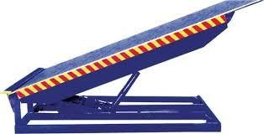

Dock Levelers
Type | Dock Levelers | PL. indicate your requirement
Make | NIHVA
Capacity in KG | 6000/9000/10000/12000/15000
Platform Width in MM | 2000
Platform Length in MM | 2500
Lip Width in MM | 2000
Lip Length in MM | 400
Working Length (Including Lip) in MM | Direct by electric Motor
Overall Length in MM | 2900
Overall Width in MM | 2000
Shut Height in MM | 480
Working Range UP/Down in MM | (+) 300 / (-) 150
Loading Platform Height from Road in MM | 1250
Dock Operation Mode | AC Power Pack Hydraulically Operated
Lip Operation Mode | Hydraulically Operated
Operation Control | Through Panel
Power Pack | Hydraulic
Drive Type | Direct by electric Motor
Motor Ratings HP | 1HP
Pump Design Flow (LPM) | 2.5
Pump Type | Gear
Safety Valve Set Pressure (Kg/Sq. Cm) | 120
Volume of Oil Receiver (Liter) | 7
No. Of Deck Cylinder | 2
No. Of Lip Cylinder | 1
Power Supply | 3 Phase
Maximum Gradient | 1:10
Clear Pit Dimensions (W x L x D) MM | 2050 X 2550 X 485
Service Weight in Kg (Approx.) | 900

We Make Possible Visit US: www.nihva.com
91 8551008333  +91 20 66304033





Email: marketing@nihva.com

